Book

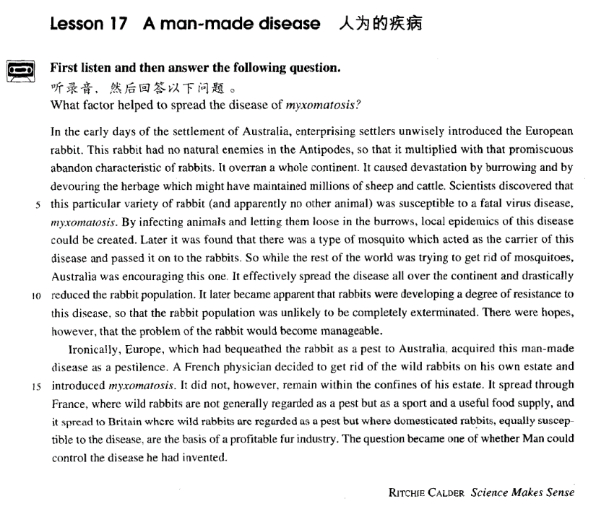

课文

In the early days of the settlement of Australia, enterprising settlers unwisely introduced the European rabbit.

在澳大利亚移民初期，一些有创业精神的移民不明智地把欧洲兔子引进了澳大利亚。

This rabbit had no natural enemies in the Antipodes, so that it multiplied with that promiscuous abandon characteristic of rabbits.

这种兔子在澳大利亚及新西兰没有天敌，因此便以兔子所特有的杂乱交配迅猛繁殖起来。

It overran a whole continent.

整个澳洲兔子成灾。

It caused devastation by burrowing and by devouring the herbage which might have maintained millions of sheep and cattle.

它们在地下打洞，吃掉本可以饲养数百万头牛羊的牧草，给澳洲大陆造成了毁灭性的破坏。

Scientists discovered that this particular variety of rabbit (and apparently no other animal) was susceptible to a fatal virus disease, myxomatosis.

科学家们发现，这种特殊品种的兔子（显然不包括别的动物）易患一种叫“多发性粘液瘤”的致命毒性疾病。

By infecting animals and letting them loose in the burrows, local epidemics of this disease could be created.

通过让染上此病的动物在洞内乱跑，就可以使这种疾病在一个地区蔓延起来。

Later it was found that there was a type of mosquito which acted as the carrier of this disease and passed it on to the rabbits.

后来又发现，有一种蚊子是传播这种疾病的媒介，能把此病传染给兔子。

So while the rest of the world was trying to get rid of mosquitoes, Australia was encouraging this one.

因此，世界上其他地方在设法消灭蚊子的时候，澳大利亚却在促使这种蚊子大量繁殖。

It effectively spread the disease all over the continent and drastically reduced the rabbit population.

蚊子把这种疾病扩散到整个澳洲大陆，效果甚佳，结果兔子的数目在为减少。

It later became apparent that rabbits were developing a degree of resistance to this disease, so that the rabbit population was unlikely to be completely exterminated.

后来，明显看出，兔子对这种疾病已产生了一定程度的免疫力，所以兔子不可能被完全消灭。

There were hopes, however, that the problem of the rabbit would become manageable.

但是，已有希望解决兔子所带来的问题。

Ironically, Europe, which had bequeathed the rabbit as a pest to Australia, acquired this man-made disease as a pestilence.

具有讽刺意味的是，欧洲把这种兔子作为有害动物传给澳洲，而欧洲自己却染上了这种人为的瘟疫般的疾病。

A French physician decided to get rid of the wild rabbits on his own estate and introduced myxomatosis.

一位法国内科医生决定除掉自己庄园内的野兔子，于是引进了这种多发性粘液瘤疾病。

It did not, however, remain within the confines of this estate.

然而，这种疾病并未被局限在他的庄园内，

It spread through France, where wild rabbits are not generally regarded as a pest but as a sport and a useful food supply,

结果在整个法国蔓延开来。野兔在法国一般不被当作有害动物，而被视为打猎取乐的玩物和有用的食物来源。

and it spread to Britain where wild rabbits are regarded as a pest but where domesticated rabbits, equally susceptible to the disease, are the basis of a profitable fur industry.

这种疾病又蔓延到了英国。在英国，野兔被当作有害的动物，可是家兔是赚钱的毛皮工业的基础，然而家兔同样易感染这种疾病。

The question became one of whether Man could control the disease he had invented.

现在的问题是，人类能否控制住这种人为的疾病。

词汇讲解

Lesson 17 A man-made disease

settlement ['setlmənt]

n. 殖民地，新的居住地；殖民（过程）；小社区；解决

settlement colony

settler colonist

colonial

semi-colonial and semi-feudal society the settlement of American West

In the early days of the settlement of Australia, enterprising settlers

unwisely introduced the European rabbit. settlement n. a small community

Except for one or two places such as Zermatt and Chamonix, which had rapidly become popular, Alpine village tended to be impoverished settlements cut off from civilization by the high mountains.

out-of-court settlement settle sth. out of court

enterprising ['entəpraɪzɪŋ]

adj. 有事业心的，有进取心的

an enterprising young man

造句：他是个有事业心的年轻人，不会满足于平淡的日常生活。

It is impossible to make more than the wildest guess at how many they kill, but they are hungry creatures, not content with only three meals a day.

This invariably wins them the love and respect of others, for they add colour to the dull routine of everyday life.

He is an enterprising young man, not content with the dull routine of everyday life.

enterprise n. 1. 事业心, 进取心

He is a man of extraordinary enterprise. enterprise n. 2. 企业

state-owned enterprise

collectively-owned enterprise township enterprise

foreign-funded enterprise joint-venture enterprise entrepreneur n. 企业家promiscuous

[prə'mɪskjuəs]

adj. 性乱的；不加选择的，随便的

promiscuous adj. 1. having sex with a lot of people

2. indiscriminate; casual promiscuous eating habits

the promiscuous distribution of diplomas licentious licence / license

abandoned abandon

Holiday shoppers are spending money with reckless abandon.

orgy n. a party at which there is a lot of drinking and sexual activity orgies of … / an orgy of …

疯狂的……；过度的……

an orgy of killing

an orgy of spending before Christmas

Even if one didn't know from concrete examples (the 1936 Olympic Games, for instance) that international sporting contests lead to orgies of hatred, one could deduce it from general principles.

go on a … binge / spree

He went on a drinking binge over the weekend. The girls went on a shopping spree on Saturday. susceptible [sə'septəbl]

adj. 易受影响的；易受感染的

be susceptible to …

Some officials are susceptible to corruption. I’m most susceptible to women’s tears.

I’m susceptible to flu. be immune to …

He is immune to criticism. I'm immune to smallpox.

immunize

inoculate sb. against … vaccinate

infect sb. with sth.

He has been infected with HIV.

Susan’s enthusiasm soon infected the whole class. spread

The disease is spreading fast. communicate / transmit a disease sexually transmitted diseases infectious / contagious / communicable

be highly ~

~ diseases catching

a catching disease X

I hope his cold isn’t catching.√ epidemic

an influenza epidemic bequeath [bɪ'kwi:ð]

v. 把……遗赠给…… bequeath sth. to …

He bequeathed everything to charity / his son. One age bequeaths its civilization to the next. leave / will sth to …

inherit sth. from sb.

He inherited a fortune from his grandfather. inheritor

inheritance / legacy

heritage

historical / cultural / literary / architectural heritage

For we know that our patchwork heritage is a strength, not a weakness. We are a nation of Christians and Muslims, Jews and Hindus, and nonbelievers.

in the early days (of …)

in the early days of spring / our marriage / the Qing Dynasty … in the pioneering days (of …)

In the pioneering days, however, this was not the case at all. in those days

In those days wandering minstrels were welcome everywhere. In those days, boxers fought with bare fists for prize money. these days

These days, people who do manual work often receive far more money than people who work in offices.

in one’s younger / school / student / army / childhood / … days unwise

ill-advised impolitic folly

Seward’s Folly

it refers to the purchase of Alaska from Russia in 1867. William Seward

Seward’s Folly Seward’s Ice Box

This rabbit had no natural enemies in the Antipodes, so that it multiplied

*with that promiscuous abandon characteristic of rabbits*.

natural enemies

Porpoises and sharks are natural enemies. the Antipodes

antipodes

do sth. with wild / gay / reckless /… abandon They danced with wild abandon.

Christmas shoppers are spending money with reckless abandon. be characteristic of …

be typical of …

Such bluntness is characteristic of him.

The creamy richness is characteristic of the cheese from the region.

With optimism characteristic of all industrialized countries, we came to accept that everyone is fit to be educated.

characterize

Bright colors and bold strokes characterize his early paintings. be characterized by …

Sleep is divided into periods of so-called REM sleep, characterized by rapid eye movements and dreaming, and longer periods of non-REM sleep.

overrun (overran overrun) v. to be present in a place in such large amounts or numbers that it is unpleasant 泛滥，蔓延

Weeds have overrun the garden.

The warehouse was overrun by / with mice. a mall overrun by / with shoppers

It caused devastation by burrowing and by devouring the herbage which

might have maintained millions of sheep and cattle.

herbage pasture

Nothing can be compared, he maintains, with the first cockcrow, the twittering of birds at dawn, the sight of the rising sun glinting on the trees and pastures.

Scientists discovered that this particular variety of rabbit (and apparently

no other animal) was susceptible to a fatal virus disease, myxomatosis.

variety

The lake has more than 20 varieties of fish. species endangered species genre

a musical / literary genre of a … nature

treaties *of* a political nature books *of* an erotic nature questions *of* an academic nature articles *of* a technical nature

let … loose

The kidnappers let him loose on a dark country lane. free … release … let … go

Please release me, let me go. For I don't love you anymore.

To waste our lives would be a sin. Release me and let me love again. liberate

Allied armies liberated France from the Nazis.

emancipate

emancipate slaves / women

the Emancipation Proclamation

Later it was found that there was a type of mosquito which acted as the

carrier of this disease and passed it on to the rabbits.

act as … serve as … function as … be used as … carrier

carry a disease

We continually wage war on them, for they contaminate our food, carry diseases, or devour our crops.

pass sth. on to sb.

I’ll pass your complaints on to my superiors. He passed his cold on to me.

communicate / transmit a disease to … get rid of … = dispose of …

It took me over half an hour to get rid of him.

There is no quicker method of disposing of patients than by giving them what they are asking for, …

I used weedkiller to get rid of the weeds in the garden. The president ruthlessly disposed of his rivals. encourage v. 促进，助长

Poor hygiene encourages the spread of disease.

all over the continent around the continent throughout the continent the continent over

Traditional custom, taken the world over, is a mass of detailed behaviour more astonishing than what any one person can ever evolve in individual actions, no matter how aberrant.

drastic adj. extreme and sudden take drastic measures

drastic cuts in government spending The size of the army was drastically cut.

It later became apparent that rabbits were developing a degree of

resistance to this disease, so that the rabbit population was unlikely to be completely exterminated.

it became clear / obvious / apparent / evident that …

It soon became clear / obvious / apparent / evident that she did not have a genuine interest in her job.

it is / was clear / obvious / apparent / evident that …

The rope had been cut, so it was obvious that the lamb had been stolen. 造句：该药有效地抑制了 (restrain) 肿瘤的生长，但是，经过一段时间 (in the course of time)，肿瘤对该药产生了一定程度的抗药性。The medicine effectively restrained the growth of the tumor, which, in the

course of time, however, developed a degree of resistance to it. there were hopes that …

there be + 无灵主语

There is always hope that in its labyrinth of musty, dark, disordered rooms a real rarity will be found amongst the piles of assorted junk that litter the floors.

This greatly reduced the speed of the ship, for there was a danger that if she travelled too quickly, this rudder would be torn away as well.

Of course, New York is the ideal place for such an interesting study, because there is no shortage of tall buildings.

Perhaps there is an element of truth in both these pictures, but few of us have had the opportunity to find out.

Apparently, there is a good deal of truth in this idea.

There is probably an element of truth in this argument, but they ignore a more basic fact that the freedom of the press is often abused.

Albert Einstein once attributed the creativity in a famous scientist to the fact that he never went to school. There is undoubtedly a truth in his

observation, but such a truth is not criticism of schools. manageable adj. easy to control or deal with

My hair is more manageable since I had it cut.

Ironically, Europe, which had bequeathed the rabbit as a pest to Australia, acquired this man-made disease as a pestilence.

bequeath sth. to sb. inherit sth. from sb. confines n. 范围

The open sea was deep and mysterious, and anyone who gave more than

a passing thought to the bottom confines of the oceans probably assumed that the sea bed was flat.

within / beyond the confines of … within the confines of the farm / the law

beyond the confines of human knowledge

It spread through France, where wild rabbits are not generally regarded as a pest but as a sport and a useful food supply, and it spread to Britain where wild rabbits are regarded as a pest but where domesticated rabbits, equally susceptible to the disease, are the basis of a profitable fur industry.

sport n. an activity that people do in the countryside, especially hunting or

fishing （狩猎，钓鱼等）乡间活动，消遣

domesticated adj. domesticated animals are able to work for people or live with them as pets 家养的，驯化的

domesticated animals such as sheep and horses

basis / bases axis / axes thesis / theses ellipsis / ellipses analysis / analyses

diagnosis / diagnoses hypothesis / hypotheses on the basis of …

Decisions were often made on the basis of incorrect information. base n. 底部；基地

I examined one of the pens closely. It certainly looked genuine. At the

base of the gold cap, the words 'made in the U.S.A' had been neatly inscribed.

It can take as long as eight days to rig up rope ladders and to establish supply bases before a descent can be made into a very deep cave.

The question became one of whether Man could control the disease he

had invented.